# L A R G O H I G H S C H O O L

International Baccalaureate Diploma Programme School Profile 2022 - 2023

## ADMINISTRATION

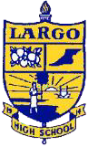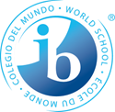

Jennifer Staten, Principal [vragovicj@pcsb.org](mailto:vragovicj@pcsb.org)

Michael Vasallo, IB Coordinator [vasallom@pcsb.org](mailto:vasallom@pcsb.org)

Kaycee Kinnard, IB Counselor

[kinnardk@pcsb.org](mailto:kinnardk@pcsb.org)

Marlee Piittmann, IB Clerk [piittmannm@pcsb.org](mailto:piittmannm@pcsb.org)

## C O N T A C T

410 Missouri Avenue

Largo, Florida 33770

Phone: 727- 588- 3758

Fax: 727- 588- 4037

[www.pcsb.org/largo-hs](http://www.pcsb.org/largo-hs)

## C O D E S

CEEB: 100925

IB: 049031

## A C C R E D I T A T I O N S & AFFILIATIONS

Cognia Accreditation

Florida Association of IB World Schools

Southern League of Colleges and Schools

## MISSION

Positive rigorous instruction designed to empower students’ learning and success in

post-secondary endeavors promoting civic engagement, global understanding, and a respect for individuals and societies.

## O U R S C H O O L

Established in 1914, Largo High School (LHS) serves the 4th largest urban city of Largo in the Tampa Bay area enrolling 2,112 scholars in the Pinellas School District. This public school offers two magnet programs, the International Baccalaureate (IB) and Exploring Careers & Education in Leadership, plus the traditional program with course options in remedial, regular, honors/pre-IB, Advanced Placement (AP), and IB Diploma. Instituted in 2013, the fast growing 4- year IB program attracts highly motivated scholars in the economically diversified central section of Pinellas County. Admission for the IB program in Pinellas County is by application only; criteria for admission includes: an academic GPA (A’s and B’s only), completion of Algebra 1 Honors, and above average standardized test scores.

***La rg o High S chool enjoys a culturally a n d economically diverse ethnic distribution.***

*25% Hispanic 16% B l ack 8% Asian 5% Multi/Other 47% White*

Over 52% of scholars qualify for free or reduced lunch.

## I N T E R N A T I O N A L B A C C A L A U R E A T E D I P L O M A P R O G R A M M E

The **IB Diploma Programme**, one of the **most rigorous curricula** offered in the world, is a highly demanding pre-university course of study, and the **most demanding program** at Largo High School.

*The* ***IB D i p l oma P r o g r a m m e*** *is structured to provide scholars with a*

***r igorous*** *and* ***b a l a n c ed*** *education, to* ***facilitate g eo g raphi c*** *and*

***cultural mobility*** *, and to* ***p r omot e international mi n d ed n e s s*** *and awareness.*

The IB D i p l oma P r o g r a m m e consists of:

**6** Core IB Subjects, **150** hours C A S (Creativity, Activity, Service), **4000** W o r d Extended Essay, **1** Theory of K n o w l e d g e course w h i c h includes a **1,600** W o r d Essay a n d Oral Presentation

Courses are examined externally in May of Grade 12, but all have at least a 20% internally assessed component. Each subject is graded on a 1 (minimum) through 7 (maximum) scale. The IB Diploma is awarded by the International Baccalaureate Organization in July after the scholar's high school graduation.

|  |  |
| --- | --- |
| **Class of 2022 Highlights** | |
| National Merit Finalists: | 3 IB Scholars |
| National Merit Commended: | 6 IB Scholars |
| SAT Average: | 1346 Composite |
| ACT Average: | 30 Composite |

# L A R G O H I G H S C H O O L

International Baccalaureate Diploma Programme School Profile 2022 - 2023

## S T A N D A R D I Z E D T E S T S A N D R E C O G N I T I O N S IB E X A M A N D D I P L O M A S P A S S R A T E (2022)

**IB E N R O L L M E N T**

50

276

Class of 2023

Total IB Scholars 2022 - 2023

**IB G R A D U A T I O N R A T E**

100% Classes of 2015 – 2022

**S C H O L A R S H I P S**

$4.6 Million ( 78 graduates; Class of 2022)

**A W A R D S**

Academic Team:

History Bowl: Scholastic Art: Basketball - Boys: Basketball - Girls: Golf - Girls:

Soccer - Boys: Soccer - Girls:

Track & Field - Boys:

5th District

National, 5th Region Gold & Silver Key 2nd District

2nd District 1st District

Region Quarterfinal 1st District

1st District

LHS IB Class: Global:

97%

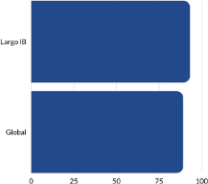86%

## S A T A V E R A G E C O M P A R I S O N (2022)

LHS IB Class: Florida:

USA:

1346 Composite

1017 Composite

1060 Composite

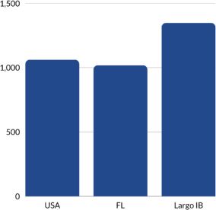

## A C T A V E R A G E C O M P A R I S O N (2022)

LHS IB Class: Florida:



USA:

30 Composite

23 Composite

21 Composite

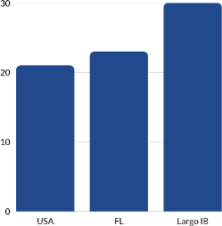

## CREATIVITY, ACTIVITY, S E R V I C E

Creativity, activity, service (CAS) is one of the **three essential**

**elements** in every student's IB experience. It involves students in a **range of activities** outside the classroom providing a

**counterbalance** to their studies. The three levels of CAS

**enhance a student's personal development** through

|  |  |
| --- | --- |
| **AP E X A M (2022)** |  |
| Students taking APs: | 172 |
| Exams administered: | 395 |
| Number of Scores 3: | 134 |
| Number of Scores 4: | 123 |
| Number of Scores 5: | 70 |
| **N A T I O N A L MERIT (2022)** | |
| National Merit African: | 1 |
| National Merit Hispanic: | 1 |
| National Merit Commended: | 6 |
| National Merit Finalists: | 3 |

**purposeful activities**, personal **challenges** , and **reflections** on outcomes and learning.

***Creativity*:** Encourages students to participate in the arts and creative thinking.

***Activity*:** Encourages students to develop a healthy lifestyle through physical activity.

***Service* :** Encourages students to volunteer within their communities for personal growth and learning.

In order to demonstrate these concepts, students are required

to undertake a **C A S project** that challenges students to:

**show initiative,**

**demonstrate perseverance,**

and **develop skills** such as **collaboration, problem solving** and

**decision making.**

# L A R G O H I G H S C H O O L

International Baccalaureate Diploma Programme School Profile 2022 - 2023

## L H S C O U R S E S A N D ACTIVITIES

|  |  |  |  |
| --- | --- | --- | --- |
| **L H S P R E - INTERNA B A C C A L A U R E A T E** | **T IONAL** | **A D V A N C E D P L A C E M E N T** | **INTERNATIONAL B A C C A L A U R E A T E** |
| Analysis of Functions | Honors | AP Calculus AB | IB Biology HL/SL |
| Anatomy/Physiology  IB MYP Algebra 2 Pre-Calculus Honors Pre-IB Biology  Pre-IB Chemistry Pre-IB English Pre-IB French  Pre-IB Inquiry Skills | Honors | AP Calculus BC  AP Chemistry  AP Computer Science Principles AP Environmental Science  AP European History AP Human Geography AP Music Theory  AP Physics 1, 2 | IB Chemistry HL/SL  IB Contemporary History HL/SL IB Dance HL/SL  IB English Language & Literature HL/SL IB French SL  IB Global Politics HL/SL  IB History of the Americas HL/SL  IB Math Analysis & Approaches SL |

Pre-IB Spanish

Pre-IB World History Spanish 5 Honors Trigonometry Honors US History Honors

*\*Non-Academic Electives not listed*

## C L A S S R A N K A N D G P A

AP Psychology

AP Spanish Language and Culture AP Statistics

AP Studio Art 2 - D

AP World History: Modern

*\* IB scholars have little room for AP coursework in their schedule due to IB Diploma Programme requirements*

IB Math Applications & Interpretation HL/SL

IB Physics HL/SL IB Spanish HL/SL IB Music HL/SL IB Theatre HL/SL

IB Theory of Knowledge IB Visual Arts HL/SL

*\*During the junior and senior years, IB scholars take three IB classes at the standard level (SL), three at the higher level (HL), and Theory of Knowledge*

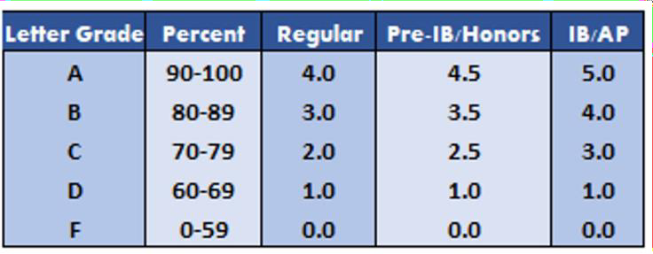The school year is divided into two semesters and students take 8 courses each semester. All high school courses taken in middle and high school are included in the grade point average (exact), and class rank. Quality points (weighted coursework) are designated with a "Q" on official transcripts. IB Diploma Programme Scholars do not have access to Dual Enrollment coursework with our local state college due to program limitations.

**U n w e i g ht e d G P A ( Class of 2022)**

3.79 Average GPA ( 78 Graduates)

4.00 GPA earned by 13 scholars

**W e i g h t e d G P A ( Class of 2022)**

4.5+ GPA earned by 37 scholars

4.0+ GPA earned by 75 scholars

3.8+ GPA earned by 78 scholars



**S T U D E N T O R G A NIZ ATIO NS**

5000 Role Models, Academic Team, Automotive, Badminton, Band/Percussion/Orchestra, Chorus, Color Guard, Dance, E- sports & Gaming, ExCEL Board of Student Advisors, Family Career and Comunity Leaders of America, Fellowship of Christian Athletes, French, Freshman Class Sponsor, Future Business Leaders of America, Gay Straight Alliance, Girlfriends Inc., Health Occupations Students of America, History Bowl Team, Hope Ambassadors, International Thespian Society, Japanese Friendship, Junior Class, Junior Statesmen of America, Key, Leadership Largo, Madrigals, Model UN, Mu Alpha Theta, Muslim Student Association, National Art Honor Society, National English Honor Society, National Honor Society, Octagon, Rho Kappa, Students Against Destructive Decisions, Science National Honor Society, Science Olympiad, Senior Class, Sophomore Class, Spanish Honor Society, Student Government Association, Tri-M Music Honor Society, Women's Education Empowerment & Equality

**A T H L E T I C S**

Baseball, Basketball, Cheerleading, Cross Country, Flag Football, Football, Golf, Soccer, Softball, Swimming, Tennis, Track, Volleyball, Wrestling

# L A R G O H I G H S C H O O L

International Baccalaureate Diploma Programme School Profile 2022 - 2023

## C O L L E G E A N D U N I V E R S I T Y A C C E P T A N C E S : C L A S S E S OF 2015-2022

American University Amherst College Andrews University



Appalachian State University Arizona State University Assumption College

Auburn University Baylor University Bentley University Boston University Brandeis University Bryn Mawr College Bucknell University

Carnegie Mellon University Champlain College Chapman University College of Charleston

College of William and Mary Colorado School of Mines Columbia University

Cornell University Dartmouth College DePaul University Duke University Eckerd College Elon University

Embry Riddle Aeronautical University Emerson College

Emory University

Fashion Institute of Technology Flagler College

Florida Atlantic University Florida Gulf Coast University Florida Institute of Technology Florida International University Florida Polytechnic University Florida Southern College Florida State University Fordham University

George Mason University George Washington University Georgetown University

Georgia Institute of Technology Georgia State University Harvard University

Harvey Mudd College Haverford College Hawaii Pacific University HEC Montreal

Hollins University Howard University

Illinois Institute of Technology Iowa State University Jacksonville University

Johns Hopkins University Johnson and Wales University Kansas State University

Lehigh University Louisiana State University Loyola Marymount

Loyola University Manhattan College Marymount University McGill University, Canada Miami University Michigan State University Middlebury College

Mississippi State University

Molloy College

New College of Florida New Mexico State

New York Institute of Technology New York University

North Carolina State University Northeastern University Northwestern University

Nova Southeastern University Oberlin College and Conservatory Ohio State University

Pace University

Pennsylvania State University Piedmont International University Purdue University

Quinnipiac University Rensselaer Polytechnic Institute Rice University

Rollins College

Santa Fe College

Savannah College of Art & Design Silliman University, Philippines Southern Adventist University Southern Methodist University

St. John’s University St. Petersburg College

Stanford University Stetson University Stony Brook University Syracuse University Temple University

Texas A&M The Citadel Trinity College

Tuskegee University

United States Military Academy University of Alabama University of Alaska

University of Arizona University of Bonn, Germany University of California University of Central Florida University of Chicago University of Cincinnati University of Colorado University of Connecticut University of Florida University of Georgia University of Illinois University of Maryland University of Massachusetts University of Miami, Florida University of Miami, Ohio University of Michigan

University of Minnesota University of North Carolina University of North Dakota University of North Florida University of Oklahoma University of Pennsylvania University of Rochester University of San Francisco University of Southern California University of South Carolina University of South Florida University of Southern California University of Tampa

**CLASS of 2022**

**BY T H E N U M B E R S**

**78** Graduates

**4.39** Average GPA

**$ 4 . 6** Million in scholarships **296** College acceptances **7%** Attending out of state

**15** Different colleges enrolled

University of Tennessee University of Texas University of Toledo University of Utah University of Virginia University of Washington University of Wyoming Vanderbilt University

Vassar College Villanova University Virginia Tech

Virginia Wesleyan University Wake Forest University

Washington University in St. Louis Wesleyan University

Yale University